Your Customized Proposal
Errors and Omissions
Quantum One Solutions, Inc
Diane Hansen, Broker
CDI Lic. No. 0G94723

Direct Line:
Customer Service: 916-774-0498
Fax: 916-751-3853

TO: Karen Ramstrum
COMPANY: Karen Lacks & Co. Real Estate

SUBJECT: Real Estate Errors & Omissions Quote
_____________________________________________________________________________________________

Attached is the quote we spoke about earlier today and the paper work / signature pages that go with it.

Please call me with any questions and/or concerns you might have.

IMPORTANT INFORMATION REGARDING BINDING COVERAGE

Please sign and complete the following items to be returned:

- SIGNED AND COMPLETED ORDER FORM
- SIGNED AND COMPLETED NO KNOWN CLAIMS FORM.
- SIGNED AND DATED SIGNATURE PAGES.

- EMAIL THE COMPLETED AND SIGNED PAPER WORK TO MY ATTENTION. PLEASE BE SURE THAT ALL PAPERWORK IS DATED THE DAY YOU SEND THE PAPERWORK TO OUR OFFICE.

- PLEASE EMAIL A COPY OF YOUR PAYMENT; YOU MAY INCLUDE A COPY OF YOUR CHECK OR THE COMPLETED PAYMENT FORM. WE DO NOT REQUIRE MAILED ORIGINALS OF PAYMENT AND PAPERWORK, AS WE PROCESS ELECTRONICALLY TO PREVENT AND DETER IDENTITY THEFT AND FRAUD.

Your Customized Proposal
Errors and Omissions
Diane Hansen, Broker
CDI Lic. No.0G94723
Karen Ramstrum
Karen Lacks & Co. Real Estate
5210 Carpenteria Ave
Carpenteria, CA 93013

Thank you for recently submitting your application for E&O insurance. We have received the following indication:
Limits of Liability Deductible Quote
Per claim / Aggregate Per claim Price
$1,000,000/1,000,000 $0/$5,000* $3,424
With contingent bodily injury/property damage $3,691

This quote includes your 3% check /cash discount
Underwritten by TruStage Insurance Group. , an Admitted carrier rated A (Excellent)XII by A. M. Best, this program is competitively priced and offers many unique benefits important to the real estate industry:
- Fair Housing/Discrimination Coverage
- Lockbox Coverage for Bodily Injury/ Property Damage
- Pollution/ Environmental Coverage for Failure to Disclose
- Coverage for the Sale of Agent Owned Properties per policy guidelines
- Open House Coverage for Bodily Injury/ Property Damage
- Subpoena Assistance
- Disciplinary Proceedings Coverage
- Mold Coverage
- Coverage for Fraudulent Funds Transfer
- Reimbursement of Expenses
- Reputation Protection Expense Coverage
- Security Incident Expense Coverage
- Public Relations Crisis Coverage/ Expenses
- Drone and Bodily Injury/Property Damage Coverage
- DEDUCTIBLE FORGIVNESS PER POLICY GUIDELINES (BASED ON MEETING THE FOLLOWING)
- A seller disclosure form was signed by the seller & acknowledged by the buyer prior to the closing;
- A Home Warranty policy was purchased prior to the closing, or waived in writing by buyer between the time the “residential real property” was listed and up to and including 30 days after closing:
- An accredited written property inspection report was performed on the property or waived in writing by the buyer prior to closing; and
- A state or local board approved standard sales contract was utilized.
- Will not apply to dual agency or agent owned Properties

This is an annual price regardless of the number of transactions your company closes.

This indication is valid until 07/20/26. Your effective date of coverage is 07/21/26. This indication includes FULL PRIOR ACTS COVERAGE and all administrative,
broker fee $342, processing, finance and risk management fees.
Your Customized Proposal
Errors and Omissions
Diane Hansen, Broker
CDI Lic. No. 0G94723

PAYMENT OPTIONS / ORDER FORM – TRUSTAGE INSURANCE

COMPANY NAME: Karen Lacks & Co. Real Estate
LIMITS: $1,000,000/1,000,000
DEDUCTIBLE: $0/$5,000*

THE FOLLOWING PAYMENT OPTIONS ARE AVAILABLE:

- PAYMENT IN FULL: $3,424 or $3,691
(PLEASE SELECT FROM ABOVE)

- PAYMENT PLAN - 11Payment Plan - 40% Down and 10 equal payments
Financed and Billing by Go To Premium Finance

Limits of Liability Deductible Total Down 10 equal
Per claim / Aggregate Per claim Due Payment Payments

$1,000,000/1,000,000 $0/$5,000* $3,609.10 $1,369.60 $223.95 *
With contingent bodily injury/property damage $3,890.50 $1,476.40 $241.41

PLEASE SELECT A PAYMENT OPTION: ___ FULL PAYMENT ___ PAYMENT PLAN

TO REQUEST COVERAGE:

Please make check payable to Quantum One Insurance Solutions and remit your down payment or payment in full along with your signed and completed paper work to my email.

** ALL PAPER WORK AND PAYMENTS MUST BE RECEIVED IN OUR OFFICE NO LATER THAN 07/20/26 IN ORDER TO BIND YOUR COVERAGE.

SUBJECT TO 25% MINIMUM EARNED UPON CANCELLATION

By signing below you agree to all terms, conditions, policies and procedures within this information:

____________________________________ ________________________
SIGNATURE DATE

EFFECTIVE DATE OF COVERAGE: 07/21/26 KAREN-5 DDH

Risk Management Advisory

We want to help you avoid potential claims and lawsuits – and a coverage denial. That means we want to hear from you anytime you have an incident.

Take a look at this coverage denial risk scenario:

A listing agent sells a property on October 1, 2015. The seller failed to disclose a non-permitted room. The buyers find out and ask the seller and listing agent about it. The buyers are a little upset, but it doesn’t seem like they are going to sue. The listing agent thinks it will be resolve between buyers and sellers and does not report this incident to their insurance company or on their renewal application.

The listing agent had a policy period from January 1, 2015 to January 1, 2016. The buyers end up suing both the seller and the listing agent March 1, 2016 – after the policy period. Since the listing agent never reported the incident until the lawsuit was filed, they had coverage denial issues as they withheld “prior knowledge” of a situation, even though they thought it was resolved in the prior policy period.

Remember, every time you renew your policy you are asked if you have knowledge of a claim or a potential claim. If it has not been reported, it may not be covered.

When to Report:

Most insurance companies urge all of their clients to file incident reports at the time an incident occurs. In this case, when the agent realized that the room wasn’t disclosed, he should have filed an incident report.

Think of it as a heads up to a potential issue. An incident report does not get reported to the carrier like a claim would. Yet, it can help avoid a coverage issue should a claim arise. It’s essential that you let us know of incidents – even if you think they’re going to go away. You don’t want a claim denied because of undisclosed prior knowledge.

This reporting requirement is common to all E&O policies. While some insurance companies don’t want to hear from you until you have a claim, many companies believe in offering better service through their Risk Management – Legal Advisory Service program and incident reporting.

Legal Advisory Service is included in many policies to address pre-claim matters and help avoid claims. Incident reporting helps mitigate coverage issues. Both help protect you.

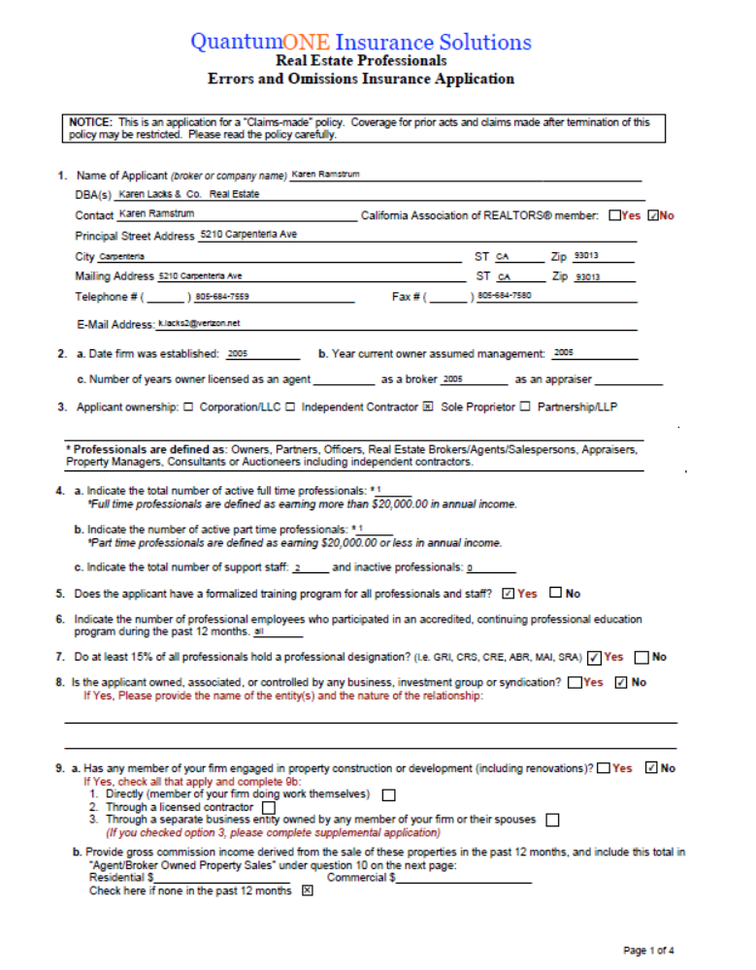

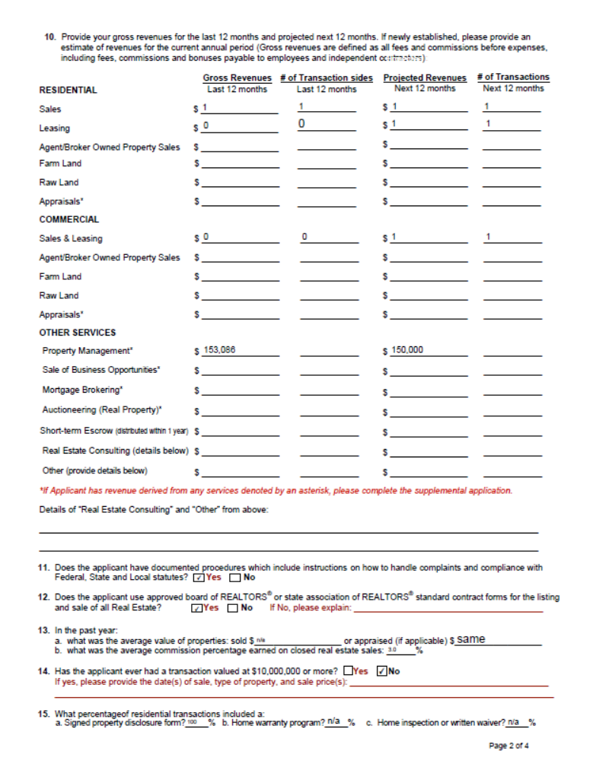

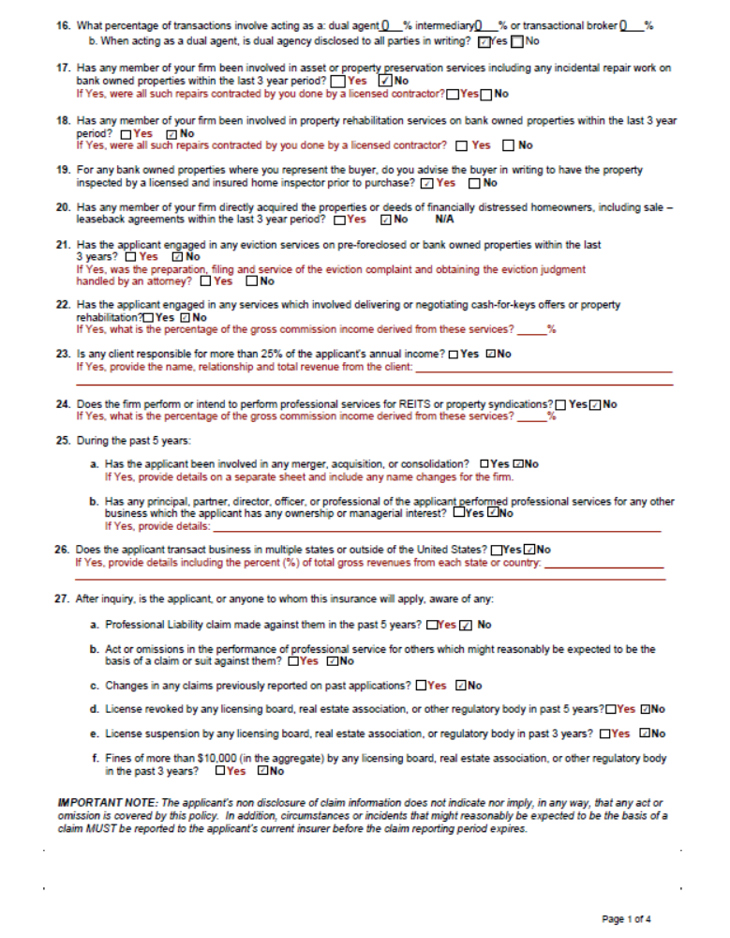

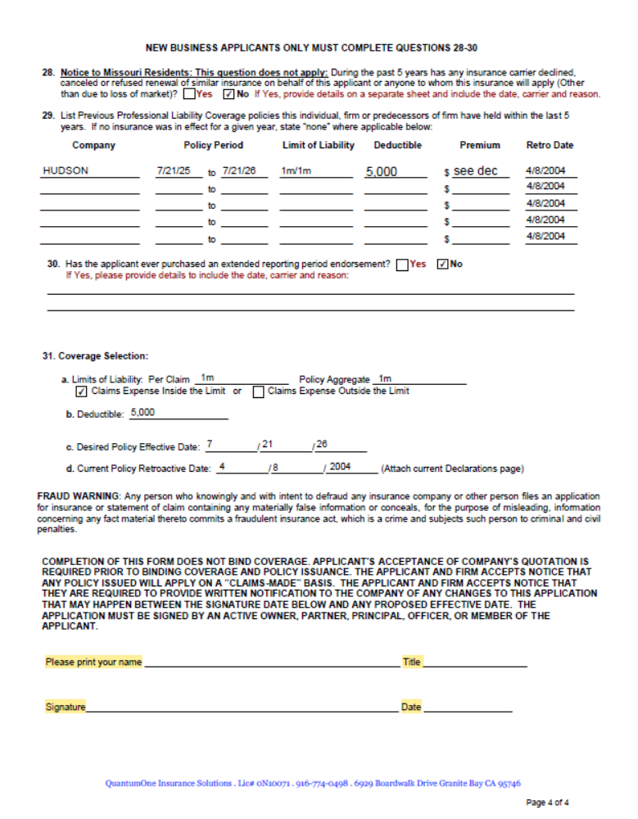

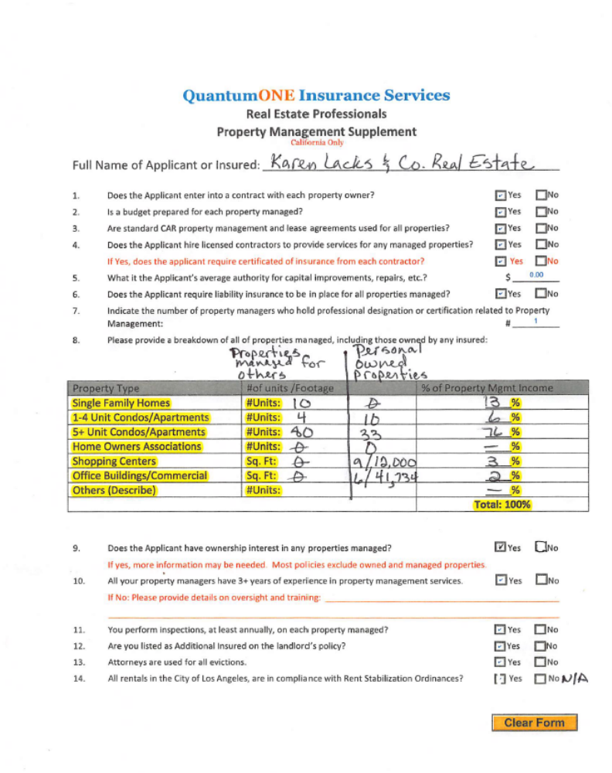

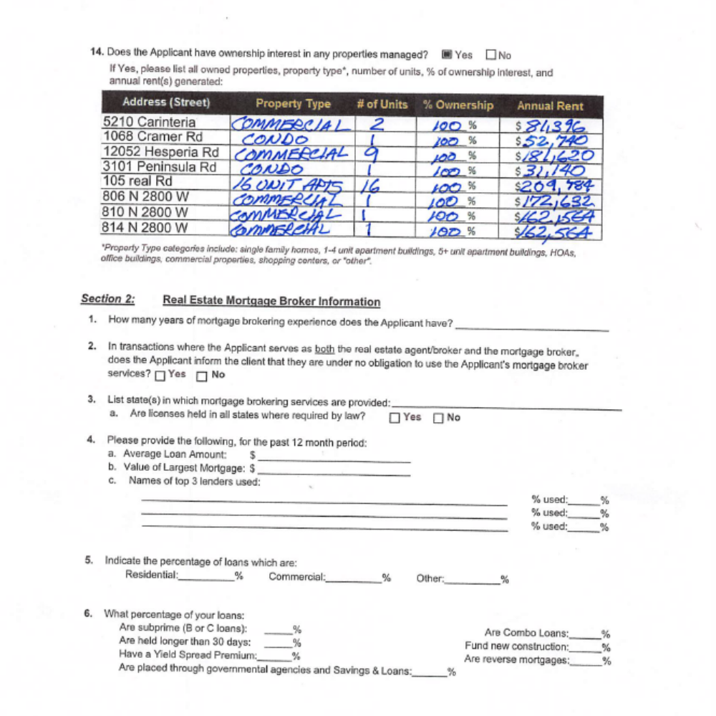

Name:_________________________________________

Signature:_______________________________________Date:______________________________

